(Approx. 1,003 words)

2013 International CES In One Word: Innovation
by Lou Torraca, President, The TUG MOAA Computer User Group, Hawaii
www.the-tug.org
Af06hi (at) gmail.com

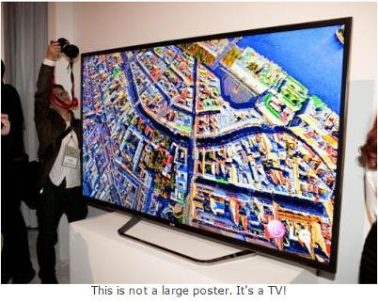

Yup… CES is back again! From the Consumer Electronics Association Press Release:

...the 2013 International CES is the largest in the show's 45+ year history, with 1.92 million net square feet of exhibit space. The previous record was 1.86 million net square feet of space at the 2012 International CES. More than 3,250 exhibitors unveiled some 20,000 new products at the 2013 CES, drawing more than 150,000 attendees, including more than 35,000 from more than 170 countries outside the United States...

"Innovation abounded at the 2013 CES and executives from every major industry that touches technology were here this week," said Gary Shapiro, president and CEO of the Consumer Electronics Association. "From amazing new products, to CEA's new book Ninja Innovation, to our new publication – It Is Innovation (i3), innovation prevailed across 37 football fields of technology at the 2013 International CES. Our event is the biggest mobile show to kick-off the year and showcase our new mobile future."

Major product launches occurred across all 15 product categories at the 2013 CES. In wireless/smartphones, highlights include the launch of Sony's Xperia Z, the Huawei Ascend Mate and ZTE Grand S. In video displays, LG featured its touchscreen Ultra HD, Sony launched the first Ultra HD OLED display, Samsung featured its bendable OLED and Hisense launched its transparent 3DTV. Digital Health and fitness launches included new products from Fitbit, Withings and BodyMedia. Audi and Lexus featured driverless vehicle technologies. For gamers, the 2013 CES saw the launch of Nvidia's Project Shield, the Oculus Rift, the Sifteo and Razer Edge. Other noteworthy products launched at the 2013 CES included: the Valve SteamBox, Tobii eye recognition technology, the Kickstarter-funded Pebble smart watch, Qualcomm's Vuforia augmented reality, multi-device connectivity from Ultraviolet, NFC technology from LG and Sony, tabletop applications from Lenovo, MakerBot's Replicator 2x and Samsung's Smart TVs with voice recognition.

It was really something to see and see, I did… as the numbers indicate there were lots and lots of things, but fortunately, the show's press events… unveiled on Sunday, all day press conferences Monday, Pepcom’s Digital experience Monday evening and Showstoppers on Tuesday evening made it a bit easier to see and feel some of the more exciting new stuff. So, with that introduction, here are just a few things I saw and thought you’d like to hear about. I’ll continue the list in my next few columns so stay tuned {:-)

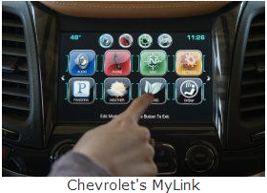

Chevrolet’s next-generation MyLink will debut on the 2014 Chevrolet Impala this spring, followed by other 2014 Chevrolet models such as the all-new Silverado full-size pickup. The newest generation of the MyLink infotainment system runs smoothly and employs icons that look, and can be rearranged, like those on a smartphone. In addition to icons covering everything from navigation to phone to music apps such as Pandora, Chevrolet’s next-gen MyLink is designed to accommodate new features and enhancements and be highly customizable. It also represents Chevrolet’s first use of natural language voice recognition that allows customers to safely place calls, enter destinations, browse media, play music and control other functions simply by telling the vehicle what to do.

Another first for Chevrolet is that MyLink can store up to 60 favorites, including radio stations (AM/FM/XM), contacts, destinations, music and other media. This feature is convenient for those who travel to the same destination regularly and want to save locations such as hotels and restaurants.

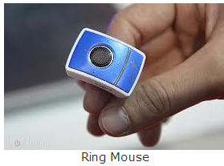

Finger mouse Genius: The product shrinks and combines a computer mouse, presenter and laser pointer into one small ring. It has been around for a couple of years, but this year, developers created rings with single functions. The newest version is a mouse only, which allows users to search the web by moving their fingers. The Ring Mouse sells for about $70.



BeeWi has an impressive list of wireless products ranging from Headphones, Transmitters, Receivers, Car Kits, Smart Devices (Toys …really for big kids… my favorite is the helicopters, but their licensed cars and camera buggy run a close second) plus multi media-keyboards, adaptors, Wi-Fi, and Mouses. Visit http://www.bee-wi.com/ to see their many impressive products.

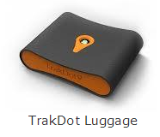

TrakDot: If u have ever lost ur luggage or even if you haven’t and u fly a lot…this one’s for u. Millions of bags either get left behind, sent to the wrong city or simply disappear completely every year. GlobaTrac has created Trakdot Luggage to give the constant flyer a little more of a sense of security. The palm-sized plastic device slips discreetly into your duffle or suitcase and updates the owner on its location via an app, SMS, email or the Trakdot website. Rather than rely on GPS, the Trakdot Luggage relies on a quad-band GSM chip and triangulation, which lasts up to two weeks on a fresh pair of AAs. Visit http://www.globatrac.com/ for pricing info including activation and annual fees.

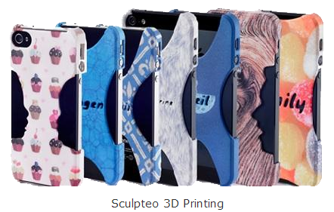

Sculpteo: This one really amazes me… ok, I know that’s not hard to do… but really… 3D printing? It’s a prototyping process that makes it possible to create an actual object from a 3D file. The object is formed by applying successive layers of solid material. - Google provides a free, easy to use application called Google Sketchup. This tool allows you to design everything you want in 3D, through an intuitive interface, and offers free 3D models for download. BTW, they can make more than smart phone covers… go to http://www.sculpteo.com/ and see all the possibilities.

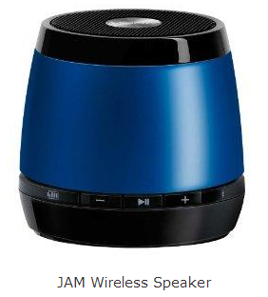

JAM Bluetooth Wireless Speaker: This one I was able to hear as well as see.

Highlights: Incredible sound quality from a small package; Easy wireless connection--works up to 30 feet away; Works with all Bluetooth-enabled devices: smart phones, tablets, and most notebooks; Lithium-ion rechargeable battery provides up to 4 hours of wireless play--no need to buy batteries; Simple on/off switch on the bottom of the unit.

That’s a wrap for now; as I said at the top… stay tuned for more.

Aloha, Lou



